**Case study: Architecture of LeNet**

LeNet refers to LeNet-5 and is a simple convolutional neural network.

**What is Lenet5?**

Lenet-5 is one of the earliest pre-trained models proposed by Yann LeCun and others in the year 1998, in the research paper Gradient-Based Learning Applied to Document Recognition. They used this architecture for recognizing the handwritten and machine-printed characters.

**The Architecture of the Model**

Let’s understand the architecture of Lenet-5. The network has 5 layers with learnable parameters and hence named Lenet-5. It has three sets of convolution layers with a combination of average pooling. After the convolution and average pooling layers, we have two fully connected layers. At last, a Softmax classifier which classifies the images into respective class.

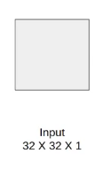

The input to this model is a 32 X 32 gray scale image hence the number of channels is one.

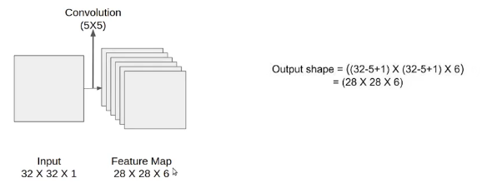

H1=32-5+1=28

W1=32-5+1=28

We then apply the first convolution operation with the filter size 5X5 and we have 6 such filters. As a result, we get a feature map of size 28X28X6. Here the number of channels is equal to the number of filters applied.

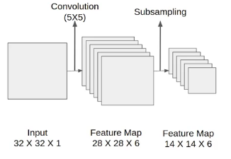

**2x2 window** (28-2)/2+1=14

After the first convolution operation, we apply the average pooling and the size of the feature map is reduced by half. Note that, the number of channels is intact.

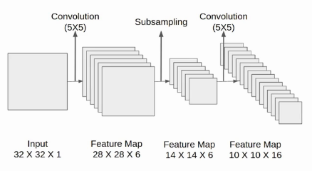

Next, we have a convolution layer with sixteen filters of size 5X5. Again the feature map changed it is 10X10X16. The output size is calculated in a similar manner. After this, we again applied an average pooling or subsampling layer, which again reduce the size of the feature map by half i.e 5X5X16. (10-2)/2+1=5

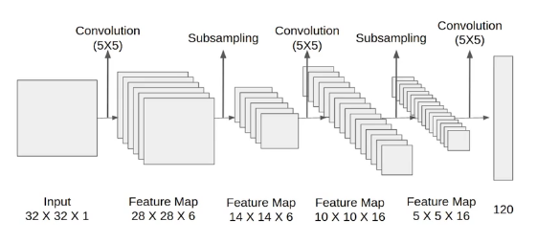

Then we have a final convolution layer of size 5X5 with 120 filters. As shown in the above image the feature map size 1X1X120. After which flatten result is 120 values.

After these convolution layers, we have a fully connected layer with eighty-four neurons. At last, we have an output layer with ten neurons since the data have ten classes.

Here is the final architecture of the Lenet-5 model.

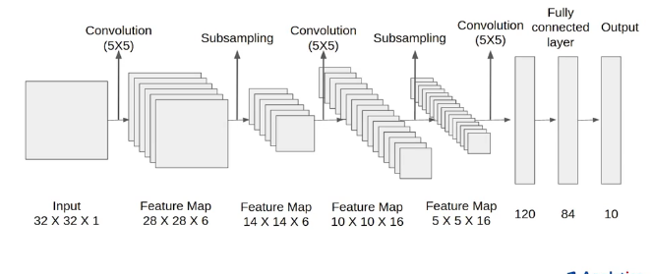

**Architecture Details**

The first layer is the input layer with feature map size 32X32X1.

Then we have the first convolution layer with 6 filters of size 5X5 and stride is 1. The activation function used at his layer is tanh. The output feature map is  28X28X6.

Next, we have an average pooling layer with filter size 2X2 and stride 1. The resulting feature map is 14X14X6. Since the pooling layer doesn’t affect the number of channels.

After this comes the second convolution layer with 16 filters of 5X5 and stride 1. Also, the activation function is tanh. Now the output size is 10X10X16.

Again comes the other average pooling layer of 2X2 with stride 2. As a result, the size of the feature map reduced to 5X5X16.

The final pooling layer has 120 filters of 5X5 with stride 1 and activation function tanh. Now the output size is 120.

The next is a fully connected layer with 84 neurons that result in the output to 84 values and the activation function used here is again tanh.

The last layer is the output layer with 10 neurons and  Softmax function. The Softmax gives the probability that a data point belongs to a particular class. The highest value is then predicted.

This is the entire architecture of the Lenet-5 model. The number of trainable parameters of this architecture is around sixty thousand.

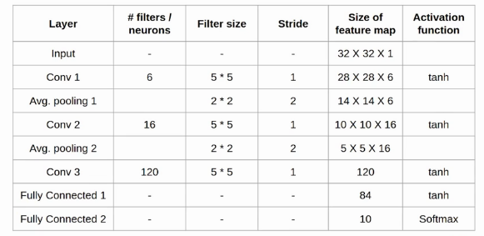

To summarize… The network has

* 5 layers with learnable parameters.
* The input to the model is a gray scale image.
* It has 3 convolution layers, two average pooling layers, and two fully connected layers with a softmax classifier.
* The number of trainable parameters is 60000.